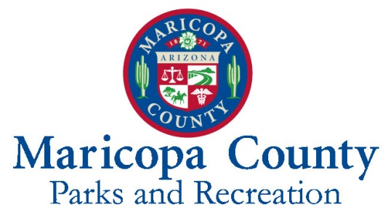
NOTICE OF SOLICITATION 180143-LOI
REQUEST FOR EXPRESSIONS OF INTEREST
FOR DEVELOPMENT, PERMITTING, CONSTRUCTION, OPERATION, MANAGEMENT AND MAINTENANCE OF A NATIVE WILDLIFE RESCUE CONSERVATION AND NATURE CENTER
AT MCDOWELL MOUNTAIN REGIONAL PARK

Introduction:

The purpose of this Notice is to conduct market research to identify potential partners through a Request for Expressions of Interest (LOI) to assist the Maricopa County (County) Parks & Recreation Department (MCPRD) in identifying potential government or non-profit private public partnership opportunities for the development, permitting, construction, operation, management and maintenance of a native wildlife rescue conservation and nature center (“Complex”) at McDowell Mountain Regional Park (“Park”). Other closely related facility proposals that fit with the MCPRD mission and vision will also be considered. The site Master Plan for McDowell Mountains Regional Park (“Master Plan”) (attached as Exhibit “A”) describes the existing plan for the Park and supports activities that will enable MCPRD to continue to add, improve or expand facilities and amenities. A Master Plan update is currently being proposed for the County’s 2018 fiscal year (July 1, 2017 through June 30, 2018). The update may consider additional facilities and amenities in the Park.

To submit a LOI for this project, respondents shall register through www.bidsync.com. To register with www.bidsync.com, please go to www.bidsync.com and click on the orange ‘Register’ link. Registration has no cost, and will allow you to access all of the bid information, bid documents, receive bid notifications, and submit a response. ONLY RESPONSES THAT ARE SUBMITTED THROUGH www.bidsync.com WILL BE CONSIDERED FOR INTEREST-NO EXCEPTIONS! For assistance, please contact BidSync Vendor Support Department via phone or email, during regular business hours: 1-800-990-9339 or agencysupport@BidSync.com

All LOIs must be submitted electronically to www.bidsync.com prior to the bid closing. The LOI will be listed under, and marked “SERIAL 180143-LOI REQUEST FOR EXPRESSIONS OF INTEREST FOR DEVELOPMENT, PERMITTING, CONSTRUCTION, OPERATION, MANAGEMENT AND MAINTENANCE OF A NATIVE WILDLIFE RESCUE CONSERVATION AND NATURE CENTER AT MCDOWELL MOUNTAIN REGIONAL PARK.”

All administrative information concerning this LOI can be located at Maricopa County Parks and Recreation website: www.maricopacountyparks.net. Any addenda to this LOI will be posted online at: www.bidsync.com. All Administrative inquiries concerning information herein shall be addressed to:
Maricopa County Parks & Recreation Department
ATTN: Emily Miller, Contract Administrator
41835 N. Castle Hot Springs Rd.
Morristown, AZ 85342
Email: EmilyMiller@mail.maricopa.gov
Telephone: 928-501-9211

The Maricopa County Procurement Code (“The Code”) governs this procurement and is incorporated by this reference. Any protest concerning this LOI must be filed with the Procurement Officer in accordance with Section MC1-905 of the Code.

Mandatory Attendance at Pre-Proposal Conference:

A mandatory pre- submittal Conference will be held at the McDowell Mountain Regional Park Nature Center, 16300 McDowell Mountain Park Dr., Fountain Hills, Arizona 85268, at 10:00 a.m. (Phoenix Arizona Time) on September 14, 2017. The Conference will start promptly at 10:00 a.m. Late arrivals may be admitted at the discretion of MCPRD’s Contract Administrator. Respondents (defined below) must represent a non-profit or government agency. LOIs from agencies that do not meet this criterion will not be accepted. Respondents are required to attend this conference as Maricopa County will not consider any LOI from Respondents that do not attend this conference.

Definitions:

Respondent means the governmental or non-profit entity seeking to provide the services required. Entity means functioning as a legal business entity recognized in the State of Arizona; and the Selected Respondent means the Respondent selected to negotiate a Use Management Agreement (“Agreement”) with County. The Agreement will become the controlling agreement between the Selected Respondent and the County.

Comments and Questions:

Respondents may submit questions using the solicitation’s BidSync “Q&A” tab prior to the closing deadline for questions. It is the respondent's responsibility to monitor the BidSync internet site for the release of any additional documents and amendments (if any). Respondents will be responsible for downloading their own copy of the documents and amendments, if any.

Background:

Maricopa County is home to one of the largest regional parks systems in the nation with approximately 120,000 acres of open space parks that include hundreds of miles of trails, campgrounds, nature centers and the Desert Outdoor Environmental Learning Center at Lake Pleasant. Currently, there are 10 regional parks in the system which we're happy to report were visited by over 2.1 million people in 2016.

McDowell Mountain Regional Park is nestled in the lower Verde River basin. In 1958, a total of 18,273 acres for the Park were leased to the County from the Bureau of Land Management (BLM) and in 1964, the land was patented to the County from the BLM pursuant to the Recreation and Public Purposes Act of 1969. Through further land acquisition, the Park has been expanded to encompass 21,099 acres. Elevations rise up to 3,000 feet along the western boundary at the base of the McDowell Mountains. Visitors enjoy a full Park program schedule and over 65 miles of multi-use trails. The Park rates as one of the most scenic with majestic mountain views. Park map is attached as Exhibit “B”.

Development and activities for the Park include:

- Nature Center (currently limited in size and scope)
- Over 65 miles of hiking, mountain biking and horseback riding trails
- RV and tent campground, including large group and youth group area campgrounds
- Playground, ramadas and picnic areas
- Event Areas
- Group Use Areas

Scope:

The scope is intended to set guidelines for the operations and management of a wildlife rescue conservation and nature center, consistent with the land use requirements outlined in the Master Plan. As noted earlier, a Master Plan update is currently being proposed for the County’s 2018 fiscal year (July 1, 2017 through June 30, 2018). The Complex, to be located within McDowell Mountain Regional Park, has a physical address of 16300 McDowell Mountain Park Dr., Fountain Hills, Arizona 85268. An aerial map of the proposed location of the Complex is attached as Exhibit “C”.

The Complex will be available for use by the general public and shall be operational year-round. The Complex may consist of the following facilities or amenities, to include but not limited to infrastructure to support below:

- Wildlife education and nature center.
- Retail sales, such as educational materials, as defined in the final agreement.
- Wildlife sanctuary and public viewing areas
- Wildlife rehabilitation center (optional)

The Complex shall include a minimum of 3,000 square feet of space for a park nature center to include the following:

- Park visitor information counter
- Retail sales area for park merchandise
- Area for park interpretive information and education displays
- Classroom
- Four staff offices
- Other amenities typical for a Maricopa County park nature center

As part of the development, the successful Respondent shall be responsible for all planning, permitting and studies (if needed), and construction, performance guarantees and associated costs.

Response Expectations:

MCPRD requires Respondent to be fully responsible for the development, permitting, construction, operations, financing, and maintenance of the Complex. The LOI should be specific and complete in every detail. It should be practical and provide a straightforward, concise delineation of Respondent’s capabilities to satisfactorily perform the proposed project(s). To be considered, the LOI must include:

- A narrative addressing all aspects of the Complex. At a minimum, items to be discussed in detail are:

  - Conservation, education, rehabilitation and sanctuary experience.
  - Proposed management and operation plan for the sanctuary, conservation, nature center, rehabilitation and/or release of native wildlife.
  - Safety considerations for native wildlife as well native wildlife interactions with the public.
  - Education programing, such as
    - Onsite programs
    - Outreach programs
    - Special Events and Fundraisers
    - Social communications
  - The financial accountability, such as sponsorships, donations and volunteering programs in order to fund the management and operation of the Complex, as well as fees payable to the County for use of Park property or alternate financial proposal that outlines both direct and indirect benefits to the County.
  - The method of financing the development costs in order to achieve the assurance of successful development of the Complex. Construction timelines, phasing (if applicable) and priorities in regards to developments of the Complex.

- Profile of Respondent including verification that the Respondent represents a non-profit or government agency.

Schedule of Events:
Notice Issued: August 24, 2017

Mandatory Pre-Submittal Conference: September 14, 2017 at 10:00 am

Deadline for written questions is (5) business days after pre-proposal Conference. Questions will not be responded to prior to the pre-proposal Conference or after the (5) business day deadline has elapsed. All questions and answers shall be posted to www.bidsync.com under the Q&A’s tab for the solicitation and must be received by the end of business, 5:00 PM Phoenix Arizona time.

Response Opening Date: October 10, 2017 at 2:00 pm

Deadline for submission of responses is 2:00 P.M., Phoenix Arizona Time, on October 10, 2017. All responses must be submitted electronically via www.bidsync.com

Instructions:

ALL RESPONSES MUST BE SUBMITTED ELECTRONICALLY VIA www.bidsync.com BY THE CLOSING DATE AND TIME. LATE RESPONSES SHALL NOT BE CONSIDERED. An organization responding to this notice should ensure that its response is complete and sufficiently detailed to allow the MCPRD to determine the organization's qualifications and capability to perform the work. Font should be Times New Roman, size 12. Lengthy responses are discouraged. The suggested length of the response is 5 to 10 pages. Supporting documentation may be attached as an appendix if needed.

All LOIs submitted and opened are public records and must be retained by the Records Manager at the Office of Procurement Services. If a Respondent believes that information in its LOI should remain confidential, it shall indicate as confidential, the specific information in its offer and submit a statement with its offer detailing the reasons that the information should not be disclosed. Such reasons shall include the specific harm or prejudice which may arise. The Records Manager of the Office of Procurement Services shall determine whether the identified information is confidential pursuant to the Maricopa County Procurement Code and the Arizona Public Records Law.

MCPRD reserves the right to conduct follow-up interviews with respondents to clarify responses, if needed.

Additional Information:

Any responses will be evaluated based on capability to achieve the desired result and if only one response is determined to be qualified, County may, at its discretion, decide to pursue a sole source contract or may discontinue the process. If multiple respondents are determined to be qualified, MCPRD may further evaluate the interested parties. Respondents should consider the following time constrains in the final LOI:

      - Updating the Master Plan is estimated to be an 18 month long process that will include, but is not limited to, the following tasks:

        - Engage stake holders and the public
        - Evaluate existing conditions
        - Perform an Environmental Assessment Study, if applicable
i. Purpose and Need
ii. Project and site analysis including cultural and biosocial resources
iii. Public involvement and scoping
iv. Draft alternative
        - Design conceptual development
        - Identify funding

2. Approvals of the final Agreement from:

- Bureau of Land Management (land patent constraints)
- Maricopa County Parks and Recreation Advisory Commission
- Maricopa County Board of Supervisors

3. Consideration for permitting from local jurisdictions.

This LOI is for planning and evaluation purposes only. This LOI does not constitute a Request for Proposal, Invitation for Bid or Request for Quotation, and it is not to be construed as a commitment by County to enter into a contract or other type of agreement. Moreover, County will not pay for the information submitted in response to this LOI, nor will County reimburse respondents for costs incurred to prepare responses to this LOI. MCPRD reserves the right to amend or withdraw this LOI at any time.

EXHIBIT A
MASTER PLAN FOR MCDOWELL MOUNTAINS REGIONAL PARK
(“MASTER PLAN”)
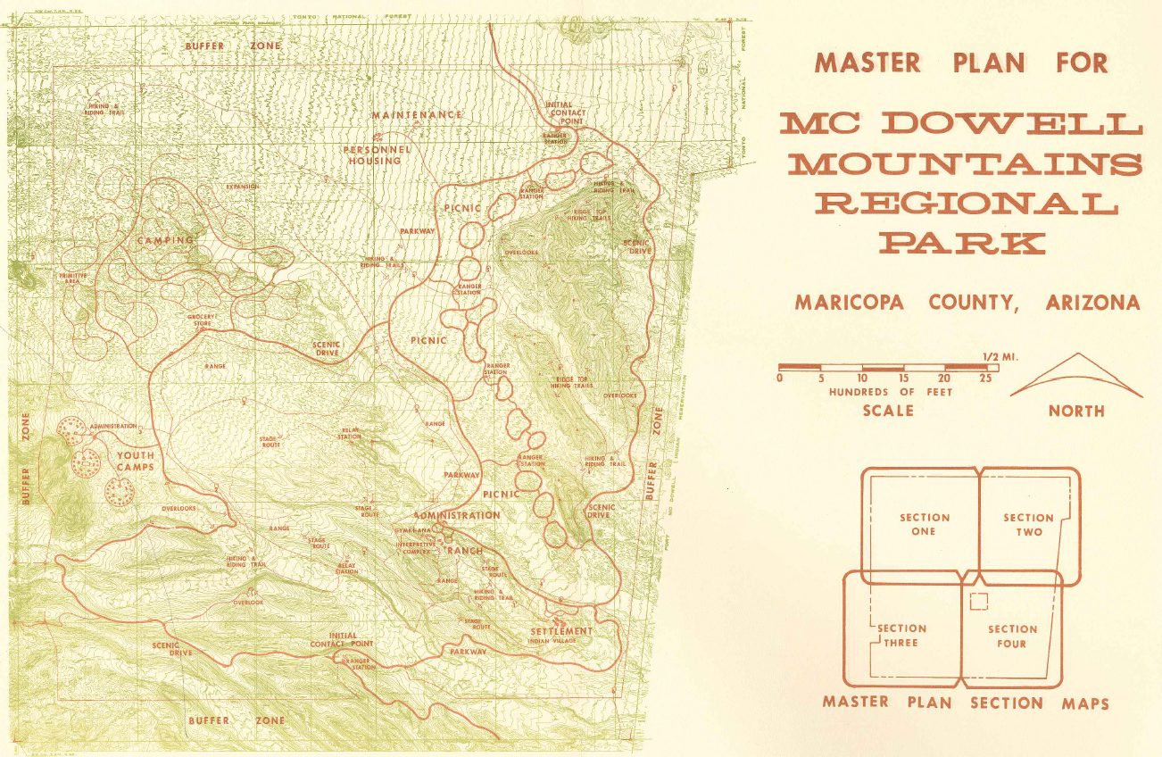
(Not to Scale)
EXHIBIT B
MCDOWELL MOUNTAIN REGIONAL PARK MAP
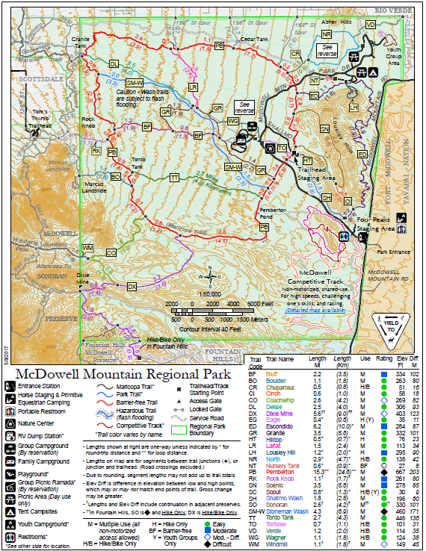
(Not to Scale)

EXHIBIT C
AERIAL MAP OF PROPOSED COMPLEX LOCATION
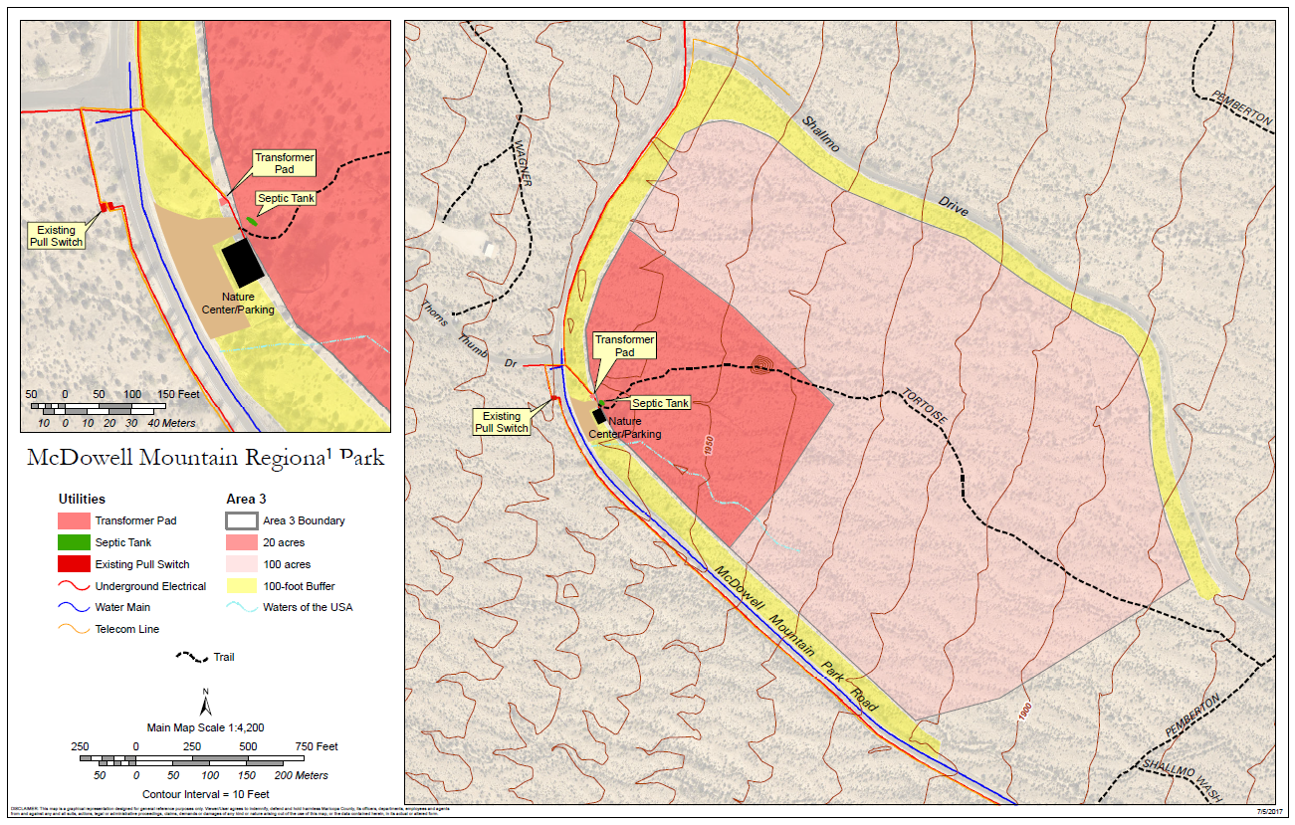
(Not to Scale)
Enlarged Proposed Site Rendering
Overall Proposed Site Rendering

